**DAY 2 ASSIGNMENT - 1**

**SDLC - Summary**

**The Software Development Life Cycle (SDLC)** is a step-by-step way to make software.

It helps developers and project managers plan, build, test, and launch good-quality software.

This process makes sure the software works well, is made the way users want, and is finished on time without wasting money.

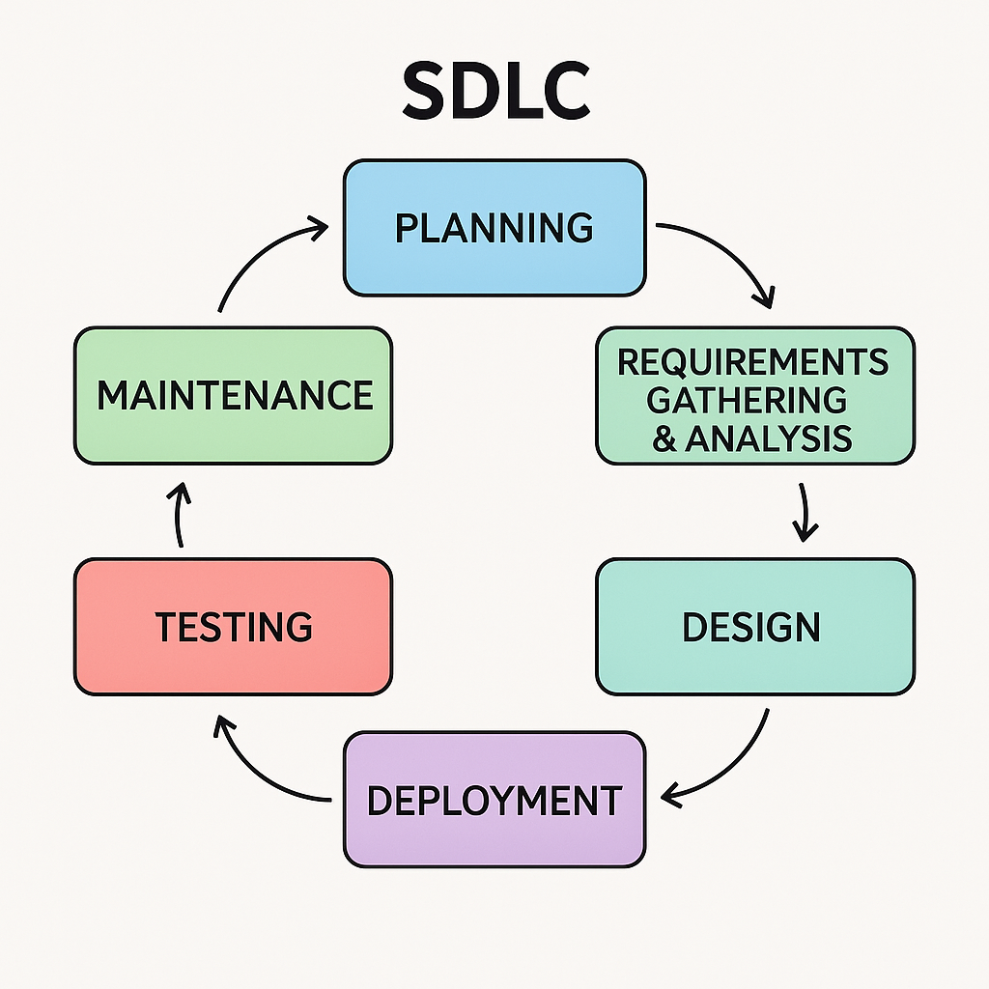

**Stages of SDLC**

1. **Planning**

This is the first step.  
We think about what we are going to make, why we need it, how long it will take, who will work on it, and how much it will cost.

1. **Requirements Gathering & Analysis**

Now, we talk to the people who will use the software.  
We ask them what features they want and what problems they want to solve.

1. **Design**

Once we know what to build, we plan for how it should look and how it will work inside.  
This can include drawings, diagrams, or models.

1. **Implementation (Coding)**

Now the real building starts.  
Programmers write the code to make the software work based on the design.

1. **Testing**

In this phase the tester will test the application and fix the bugs

1. **Deployment**

After successful testing, the software is deployed to the production environment

1. **Maintenance**

Post-deployment, the software is monitored for issues and updated as needed. This phase includes bug fixing, upgrades, and performance improvements.

**Advantages of SDLC:**

**Clear Steps** – It gives a step-by-step plan to build software.

**Better Planning** – Helps plan time, money, and people needed.

**Good Quality** – Makes sure the final software works well and has fewer bugs.

**Fewer Mistakes** – Problems are found early and fixed quickly.

**Saves Time & Cost** – Avoids rework by doing things right the first time.

**Easy to Update** – Future changes or fixes are easier to do.

**Happy Customers** – Software is made the way users want it.